**KIOSTFOAM Installation manual**

**1. OpenFOAM installation**

Please refer to OpenFOAM installation link below

os : ubuntu 14.04 기준

<https://openfoam.org/download/2-4-0-ubuntu/>

os : ubuntu 16.04 기준

https://openfoamwiki.net/index.php/Installation/Linux/OpenFOAM-2.4.0/Ubuntu#Ubuntu_16.04

**2. Waves2FOAM 설치**

Waves2FOAM 매뉴얼 (manualWaves2Foam_v090.pdf)의 Installation of Wave2FOAM 참고 (p10)

※ gfortran 설치 확인(설치 : sudo apt-get install gfortran)

2.1 Waves2FOAM required library installation

|  |
| --- |
| sudo apt-get install git  sudo apt-get install libgsl0-dev |

2.2 Wave2FOAM installation

|  |
| --- |
| mkdir -p $FOAM_RUN/../applications/utilities  cd $FOAM_RUN/../applications/utilities  svn co http://svn.code.sf.net/p/openfoam-extend/svn/trunk/\  Breeder_1.6/other/waves2Foam  cd waves2Foam  ./Allwmake |

2.3 Check installation and execution status using the command below (<Figure 1>)

|  |
| --- |
| waveFoam -help |

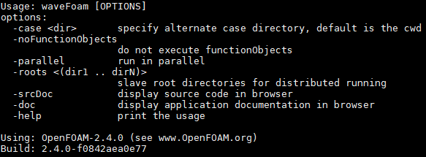

<Figure 1> waveFoam -help

**3. KIOSTFOAM installation**

3.1 Copy files below to /OpenFOAM/delft3d-2.4.0/applications/utilities/waves2Foam waves2FoamKIOST_V1.4.1.tar

- waves2FoamKIOST_V1.4.1_patch.tar

- waves2FoamKIOST_V1.4.1_cnoidal.tar

3.2 Unzip the file

|  |
| --- |
| tar xvf waves2FoamKIOST_V1.4.1.tar  tar xvf waves2FoamKIOST_V1.4.1_patch.tar  tar xvf waves2FoamKIOST_V1.4.1_cnoidal.tar |

3.3 Copy files below to /OpenFOAM/delft3d-2.4.0/applications/utilities/waves2Foam/bin

- bashrc

- bashrc.org

3.4 KIOSTFOAM installation

Go to /home/delft3d/OpenFOAM/delft3d-2.4.0/applications/utilities/waves2Foam and type command below

|  |
| --- |
| ./Allwclean  ./bin/install.add  ./Allwmake |

3.5 confirm execution using the command below (<Figure 2>)

|  |
| --- |
| waveIWMDyMFoam -help |

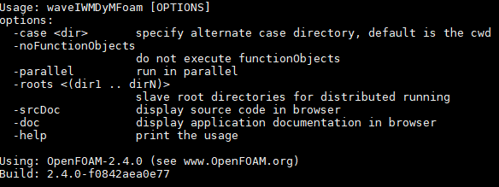

< Figure 2> waveIWMDyMFoam -help